



**Applied Physics for**

**Scientists and Engineers**

**Lab Report: Finding Resistance by Color Coding Method:**

**Submitted To**

Sir. Haseen Ullah Jan

**Submitted by**

Anees ur Rehman Nazar Computer system engineering Fall 2021

Sec C Roll No. 30799



**Apparatus:**

Following apparatus are needed to carry out this verification:

1. Different resistors with color bands.
2. Ohm meter i.e. Multimeter.



**Procedure:**

The resistance of a given resistor can be found by following method:

1. First band will give tens number in numerical value of the resistance.
2. Second band will give unit number in numerical value of resistance.
3. Third band gives the value of in numerical multiple of ten for the first value.
4. Fourth band gives the resistance tolerance.

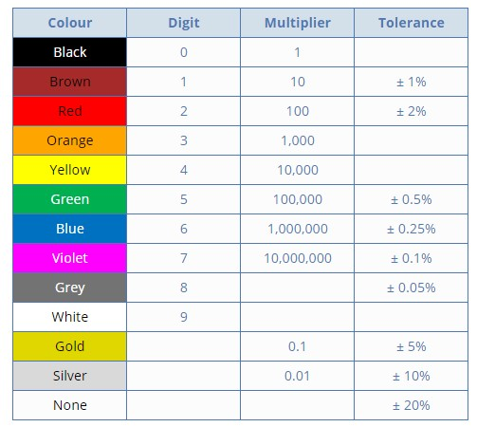

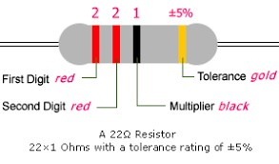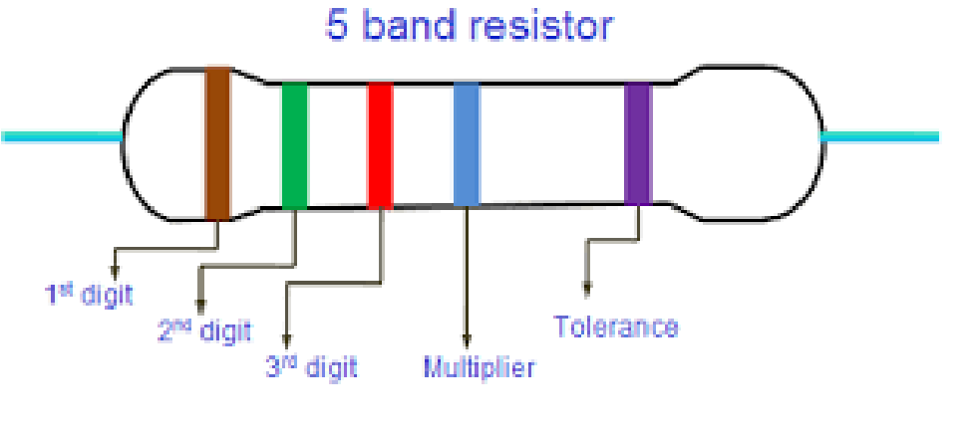



**Readings:**

|  |  |  |  |  |  |  |  |
| --- | --- | --- | --- | --- | --- | --- | --- |
| S. No. | 1st Band | 2nd Band | 3rd Band | 4th Band | Resistance in  Ohms Ω | Readings of Ohm meter | Error |
| 1. | 2 | 2 | 101 | ±5% | 22x 101 ±5% | 21.7x 101 Ω | 0 |
| 2. | 1 | 5 | 103 | ±5% | 15x 103 ±5% | 14.3x 103Ω | 0 |
| 3 | 4 | 7 | 103 | ±5% | 47x 103 ±5% | 0.7 Ω | 0.206 |
| 4. | 6 | 8 | 10−1 | ±5% | 68x 10−1 ±5% | 6.9 Ω | 0 |
| 5. | 4 | 3 | 102 | ±5% | 43x 102 ±5% | 4.25K Ω | 0 |
| 6. | 1 | 0 | 107 | ±5% | 1x 107 ±5% | 9.62M Ω | 0 |
| 7. | 1 | 0 | 105 | ±5% | 1x 105 ±5% | 0.956M Ω | 0 |